**RIPHAH INTERNATIONAL UNIVERSITY, ISLAMABAD**



**Lab 8**

**Bachelors of Computer science – 5th semester**

**Subject:** Operating System Lab

**Submitted to:** Ma’am Kausar Nasreen Khattak

**Submitted by:** Areeba Sadaqat

**Sap Id:** 47633

**Date:** 8th October, 2024

**Lab Task:**

**Note:** Include screenshots, required to illustrate your explanation for all Questions.

**Q1: Write a C/C++ program that uses the fork() function and the logical AND (&&) operator.**

This C++ code uses fork(), a system call that creates a new process.

• The code contains two fork() calls inside the condition of an if statement: if(fork() && fork()).

• This means the program will create two child processes (one for each fork()).

• The first fork() creates a child process.

• The second fork() creates another child process.

• The condition fork() && fork() checks if either fork() succeeds. If both creates a child, it runs the block inside the if statement, which has another fork().

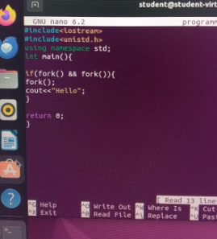

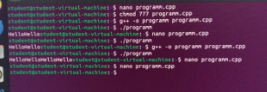

**Q2: Write a C/C++ program that uses the fork() function and the logical OR (II) operator.**

* The code contains two fork() calls inside the condition of an if statement: if(fork() || fork()).
* This means the program will create two child processes (one for each fork()).
* The first fork() creates a child process.
* The second fork() creates another child process. The condition fork() || fork() checks if either fork() succeeds. If either creates a child, it runs the block inside the if statement, which has another fork().

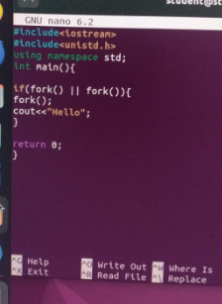



**Q3: Write a C++ program that uses fork() to create a child process. Use an if-else statement.**

This C++ code now prints either **"My name is Areeba**" or "**My bestie name is Ayeza**" depending on the outcome of the fork() calls.

* Each time fork() is called, a new child process is created, duplicating the current process.
* The fork() system call returns 0 in the child process and a positive integer in the parent process.
* The if condition is true only if both fork() calls return non-zero.
* A third fork() is called, which creates another child process.
* If the condition is false (at least one fork() call returns 0).The else block executes.

